# MLFlow Implementation using google colab

1. Install mlflow library on your google colab using “*!pip install mlflow*” command
2. Import mlflow libraries and add logging code as mentioned in the image below

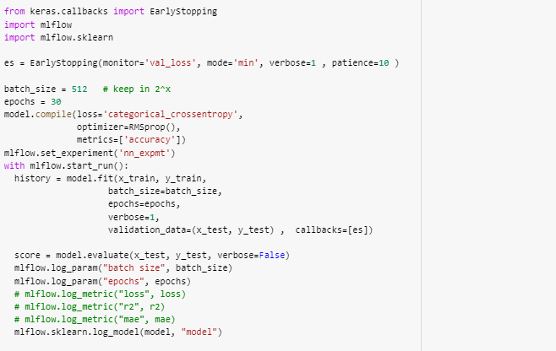

1. Install Backup and syn from Google app on your desktop. <https://www.google.com/drive/download/>
2. Sync folders from Google drive where your model is written
3. Run your model with the mlflow code embedded in it as mentioned in point 2.This creates mlrun folder in your model folder
4. Open Anaconda prompt
5. Go to local google drive where your model folder is synced
6. Run Jupyter lab command
7. Install mlflow library using “*!pip install mlflow”* command
8. Run “*!mlflow ui*” command on your jupyter lab
9. Go to the browser and type <http://localhost:5000> on your url tab
10. You can see your experiments on your browser